UR- CST
Gako Campus
Computer Engineering
year 3
Module: Mobile communication

Group members:
Janvier NSHIMIYIMANA 223026679
Blandon ASHIMIRWE 223026675
Gilbert HIRWA NTWALI 223026689

DART PROGRAMMING LAB 1

PART 1: FUNCTIONS
question 1
Write a Dart function named `welcomeMessage` that prints a welcome message for the school system
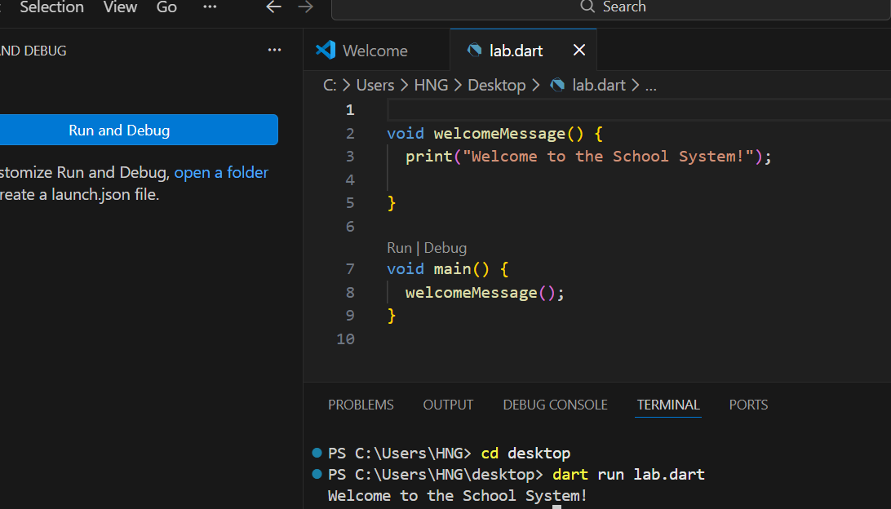

Question 2. NAMED PARAMETER function
Write a function named `createStudent` that uses named parameters (`name` and `age`) and prints the student details
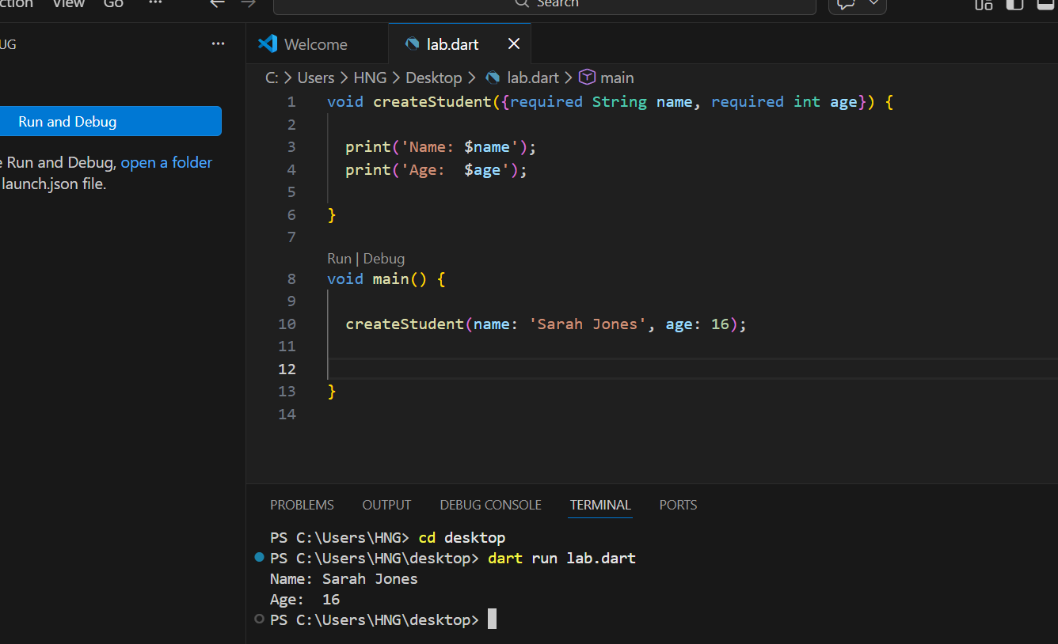
Q3: Function with required and optional positional parameter
Write a function named `createTeacher` with one required parameter `name` and one optional parameter `subject`. If subject is not provided, print 'Subject not assigned'.
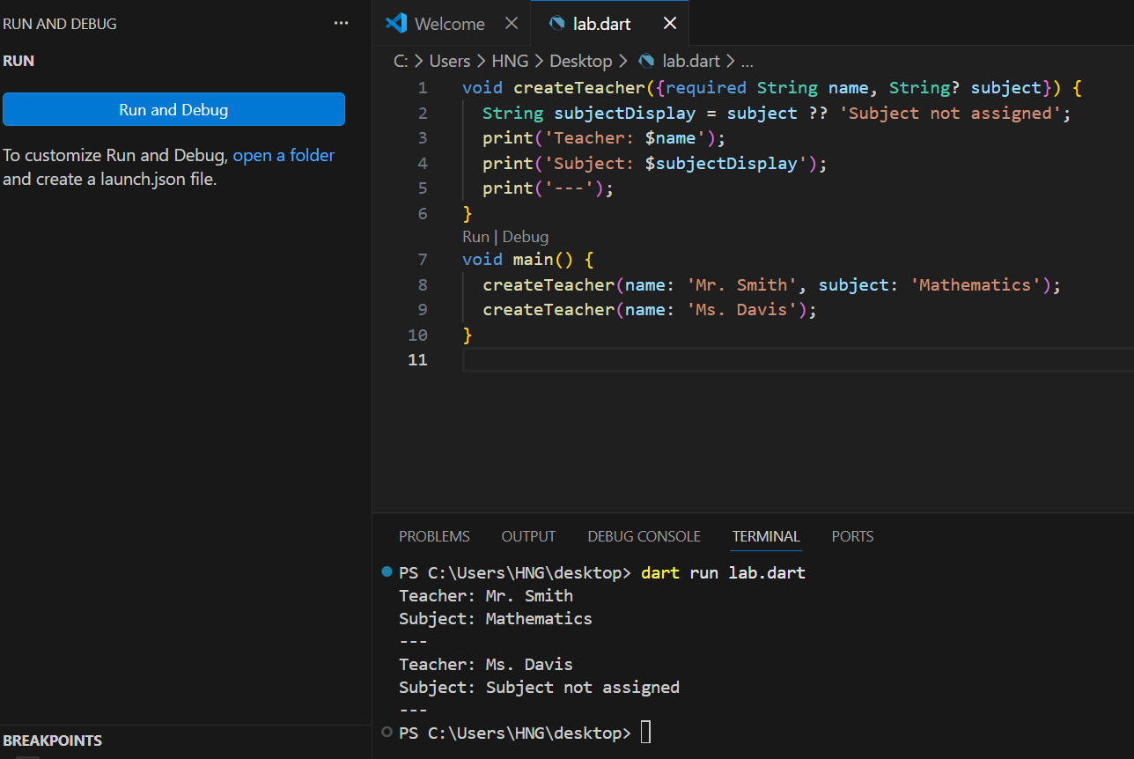

PART 2: CONSTRUCTORS AND CLASSES
Q4&q5. A class named `Student` with `name` and `age`,
and an object of `Student` and print the student’s name and age.
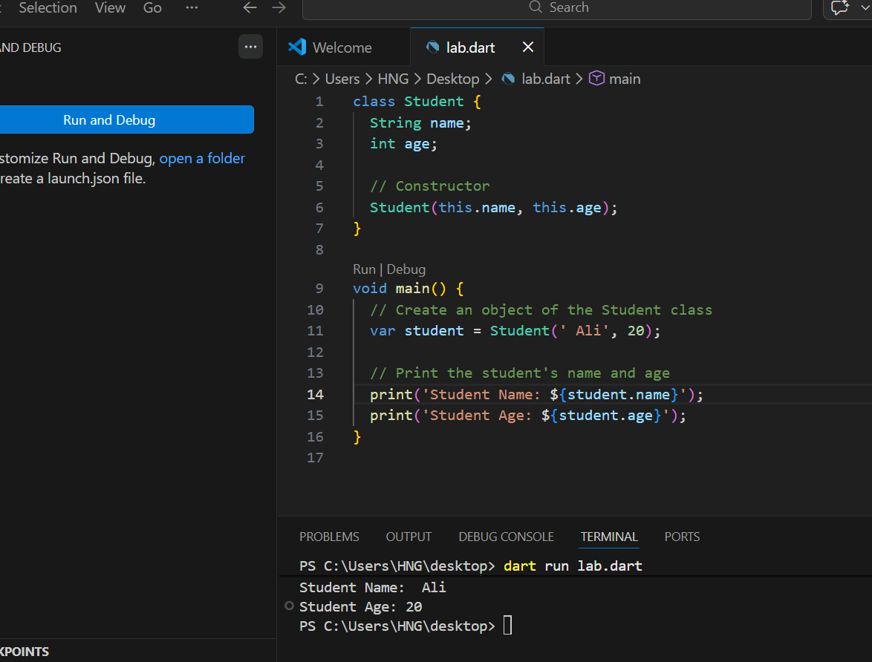

Part 3: INHERITANCE
Q6&7 A class `Person` with a variable `name` and a function `introduce()` that prints the name therefore Make `Student` inherit from `Person` and call `introduce()` from a `Student` object
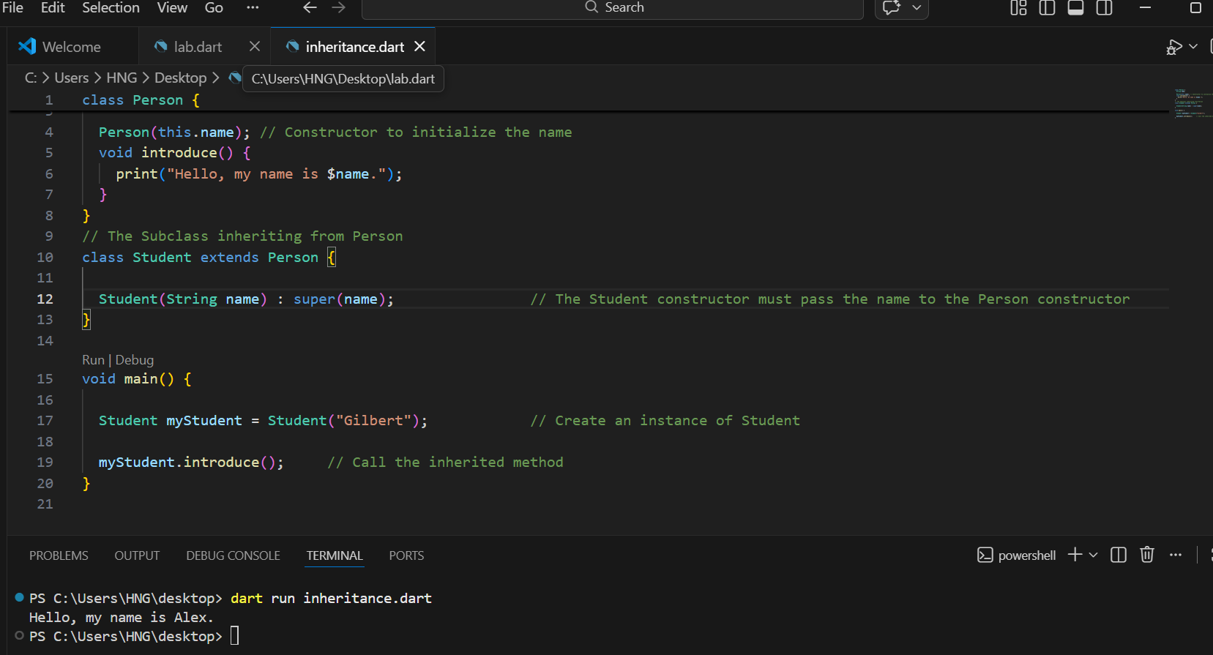

PART 4: INTERFACES
Q8 & Q9. An abstract class `Registrable` with a function `registerCourse(String courseName)` and Student` implement `Registrable` and implement `registerCourse` to print the student name and course.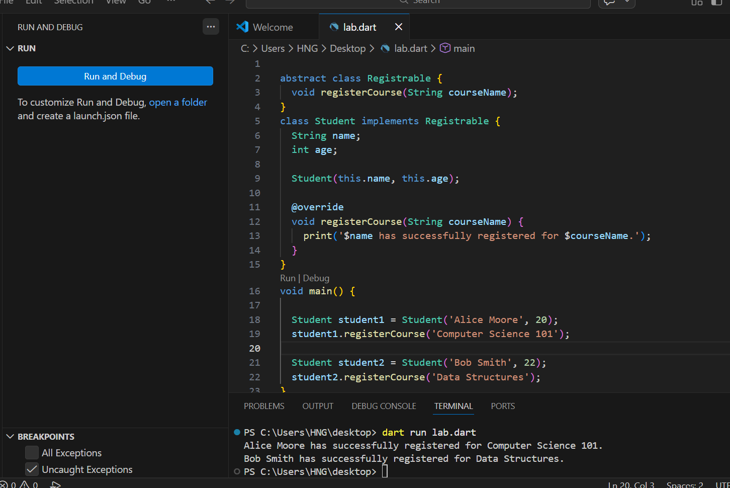

Part 5: MIXINS
Q10&11. A mixin `AttendanceMixin` that stores an attendance counter and has a function `markAttendance()` to increase attendance and
Apply `AttendanceMixin` to `Student`. Mark attendance 3 times and print the attendance
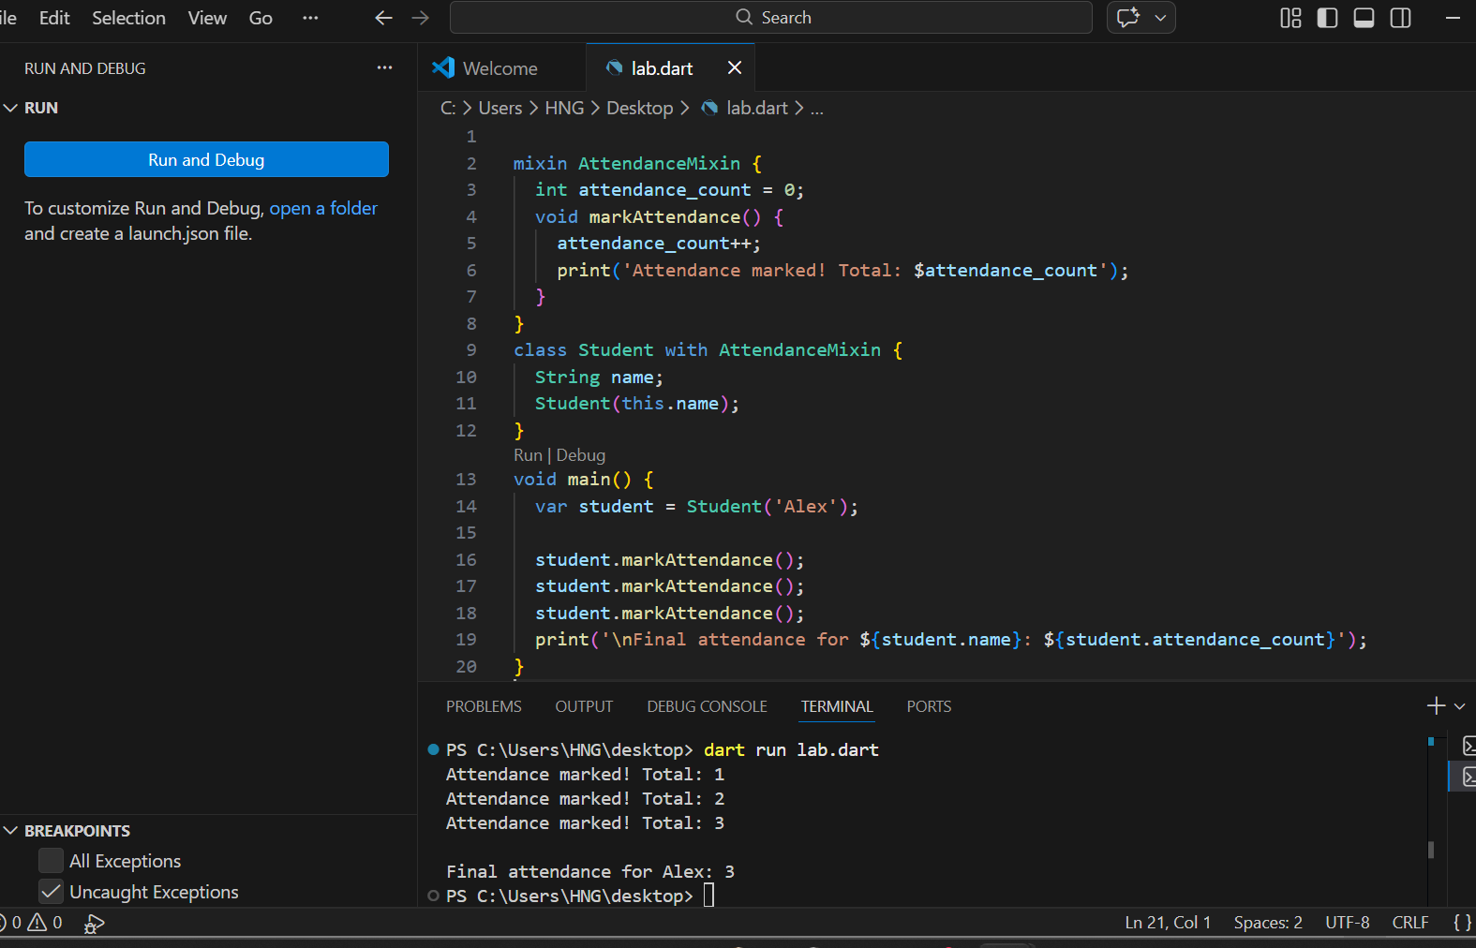

PART 6: COLLECTIONS
Q12: Create a List storing multiple `Student` objects. Add 3 students
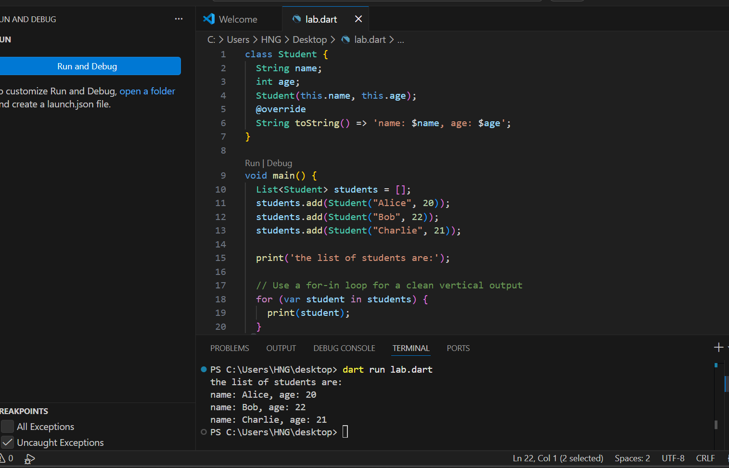

Q.13: Create a Map where the key is student ID and value is a `Student`. Print all student names
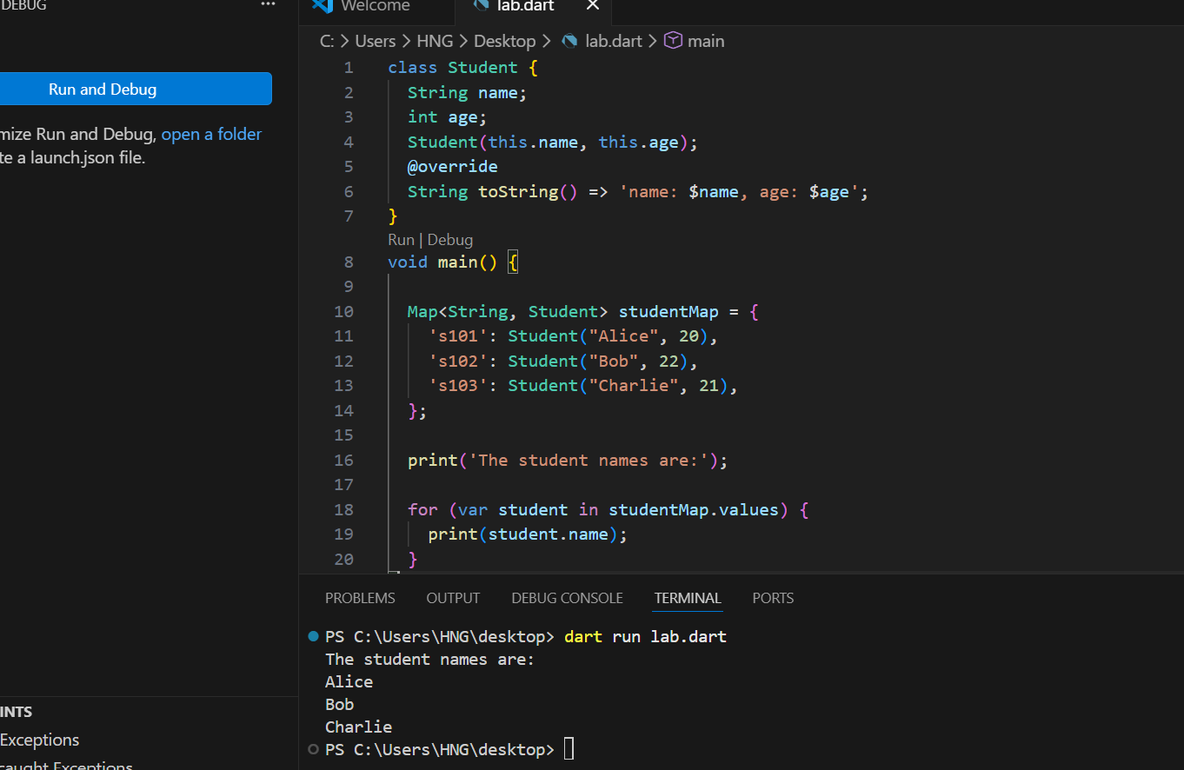

Part 7: Anonymous and Arrow Functions
Q14: Use an anonymous function to print all student names from the list.
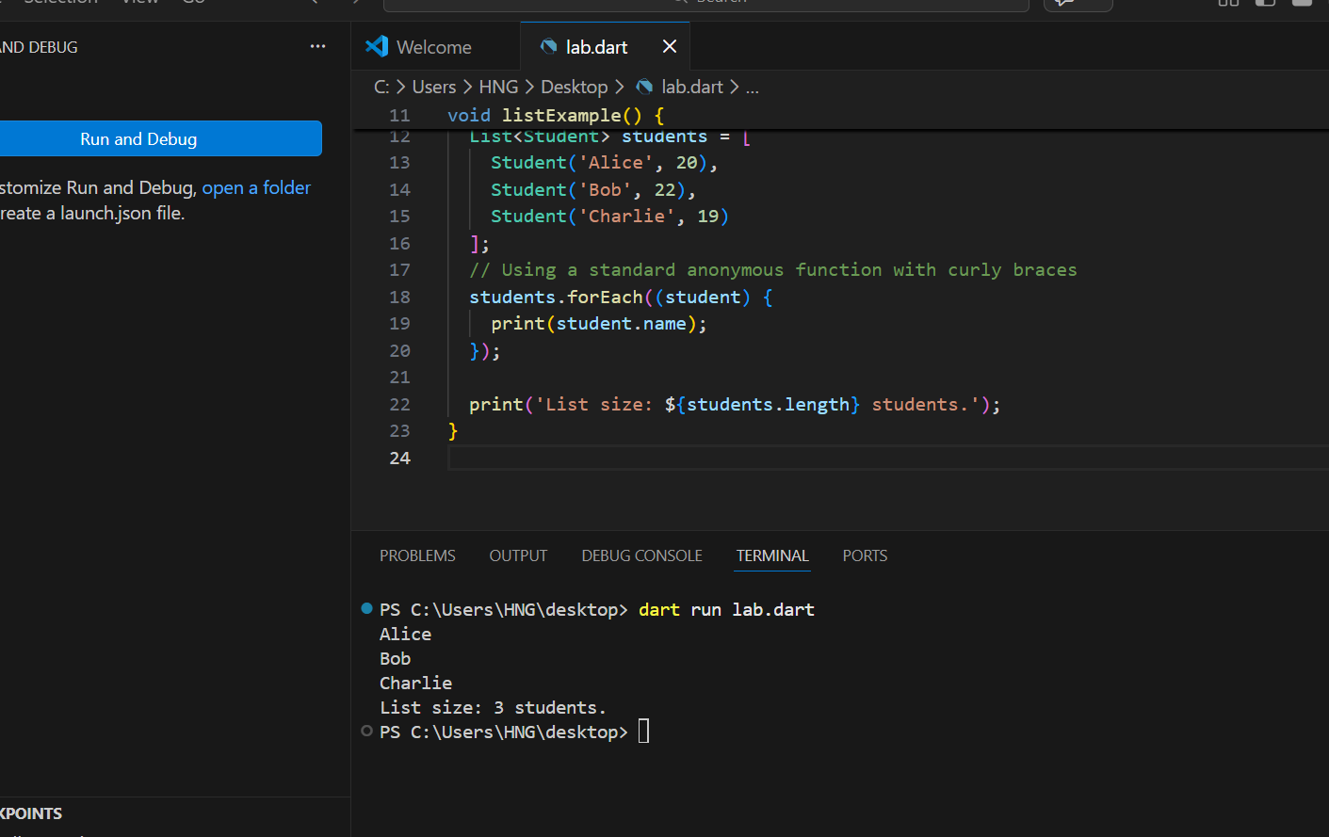

Q15.Write an arrow function that takes a student name and prints a greeting message.
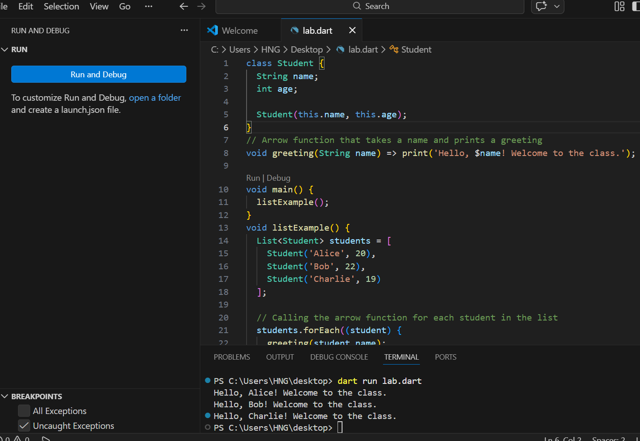

PART 8: ASYNCHRONOUS PROGRAMMING
Q16: Write an async function `loadStudents()` that waits 2 seconds and returns the list of students
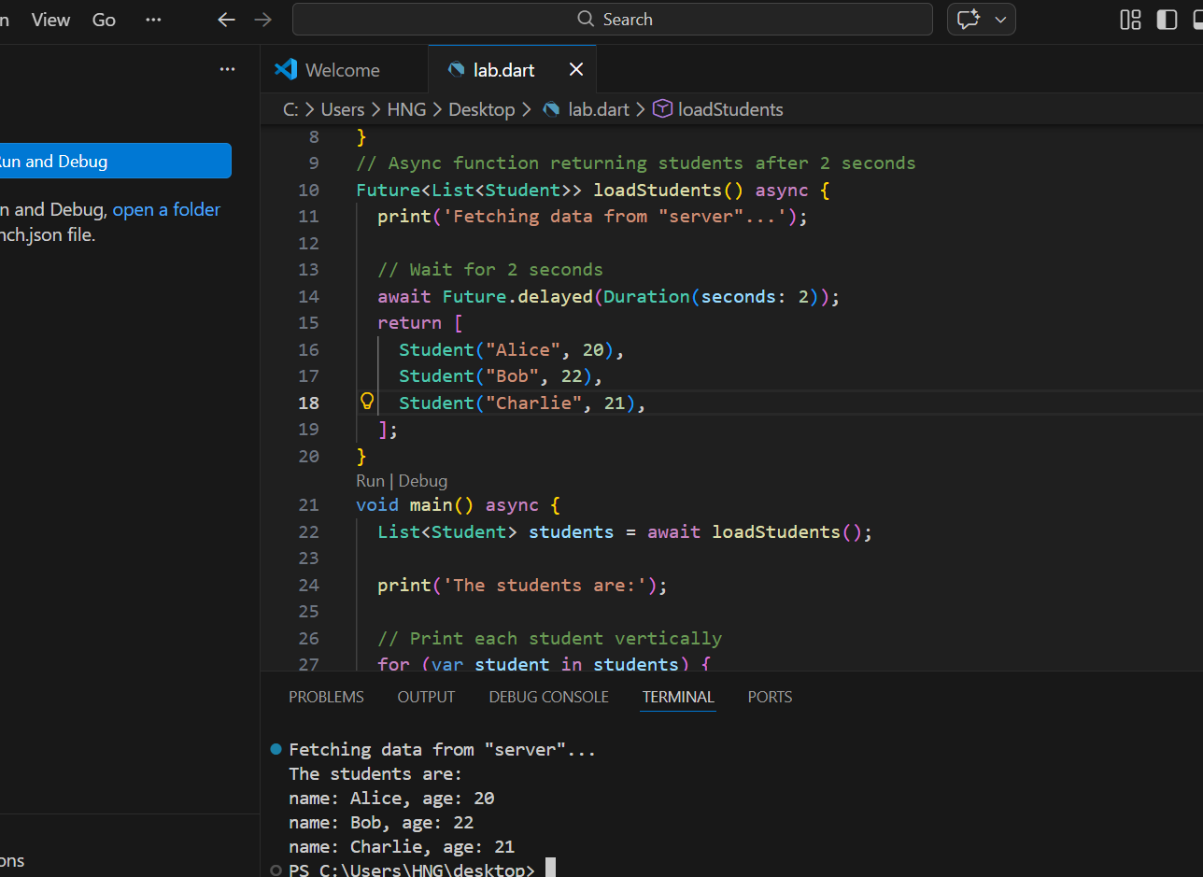

Q17: In main(), call `loadStudents()`, use await, and print the number of students loaded.
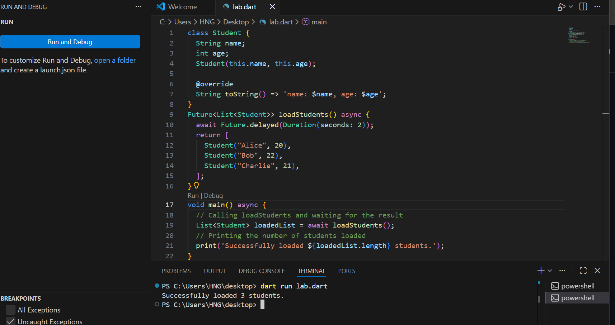

PART 9: INTEGRATION CHALLENGE
Q19: Create a new mixin `NotificationMixin` that prints a message when a student is registered to a course. Apply it to `Student`
